Preface

This system belongs to the operational management system.
This system was proposed and drafted by the Ministry of Science and Technology Innovation.
This system is interpreted by the Ministry of Science and Technology Innovation.

Management Procedure for tooling Repairing

1 Scope
According to the requirements of tooling rework , this paper specifies the process of tooling rework and inspection after rework , so as to ensure the intact rat .
This procedure is developed according to the requirements of GLC1407.

2 Referenced Documents

GLC231008 Management Procedure for Quality Records

GLC14070301 Management Procedure for Tooling Usage
GLB130304-04 Management Instruction for Tooling Tag and Identification

3 Forms

3.1 Prescribed Forms
FM1407-55 Rework Request Sheet of Tooling
FM1407-41 Disposition Sheet for Tooling Damage and Loss
FM1407-51 Equipment inspection Request Form
FM1407-85 Process Equipment Rework Plan Review From

3.2 Referenced Forms
FM1407-7 Tooling Forbidden
FM1407-39 Limitation Usage of Tooling
FM1407-49 Tooling application management account

4 Terms and definitions

4.1 Repair
Repair means to perform the repair to the wear or damage part of the tooling so as to make it meet the drawing.
4.2 Rework
Rework means to perform actual modification to the tooling. The modification may influence or may not influence the fit form or function of the tooling. It may be caused by engineering or process change.
The repair and rework mentioned in this article indicates the above-mentioned condition.

5 Responsibilities

5.1 Tooling user unit will be responsible for performing tooling rework procedures and will put forward those scraped tooling being in need of remaking.
5.2 Tooling Office of Technological Innovation Department will be responsible for confirming and modifying tooling drawings for reworked tooling and scraped tooling in need of remaking.
5.3The project manager of the project management Department approved the overall tooling scrap, communicated with customers and reached tooling scrap and customer feedback.

6 Requirement

6.1 Tooling rework
6.1.1 Tooling will be reworked when the following situations occurs:
（1）During tooling verification, parts or components processed by the tooling do not meet the requirements of product drawings.
（2）When the tooling is damaged for some reason, but it can be repaired according to the original tooling drawing, and can meet the requirements of use.;
（3）When it is necessary to perform partial repair on tooling due to modifying product drawing;
（4）When there was mismatch during tooling using process;
（5）Normal use of tooling will be affected because of slight wear or short of components.
6.1.2 When the tooling is required to be reworked, the user shall fill in FM1407-49. When filling in, the defect contents and causes shall be truthfully explained, and the warranty period of corresponding tooling after rework shall be given. The warranty period of assembly tooling is 30 units, and that of parts tooling is 3 batches.
6.1.3 Tooling user unit will go to Tooling Office perform the following signing and confirmation procedure by using form FM1407-49;
6.1.4 The rework of hydraulic operation system on assembly tooling due to production necessity but not decided by the Tooling Designer will be responsible by Technical Innovation and Facility Investment Office.
6.1.5 After completing the confirmation formalities for the signature of the rework tooling, the production control office of the tooling user unit shall hold FM1407-49 and the tooling drawings the rework tooling required, and go through the dispatching formalities in the Tooling Office.
6.1.6 When there was mismatch on product, it is necessary to verify tooling and come to a conclusion. Technical Office (responsible for master tooling) or tooling user shop will fill in form FM1407-51, and then go to Tooling Office to assign the job, and Tooling Office will perform inspection, inspection result will be sent to Technical Office or Tooling User unit.
6.1.7 If most of the detail parts or components on tooling being scraped or tooling can not be reworked due to major structural modification, Tooling Office will notify tooling user unit to perform on-site study, when confirmed it cannot be reworked, scraping procedure will be conducted separately.
6.1.8 Paragraph 6.1 in this procedure will be followed for tooling made by tooling user shop, user shop will follow its sole discretion to dispose the rework of the tooling.
6.1.9 If tooling needs to be reworked, tooling user Quality Engineering Office shall attach FM1407-7 or FM1407-39 when going through the FM1407-49 approving process; Tooling user unit Quality Engineering Office will remove FM1407-7 or FM1407-39 after reworked tooling is checked to be acceptable.
6.1.10 If the tooling rework is due to damage or loss, then fill in FM1407-41. After getting the permission of rework from Tooling Office, the Tooling user unit shall fill in FM1407-49 and go to the Tooling Office to get it signature and assignment and then perform the rework.
6.1.11 For the tooling rework due to changing tooling drawing, the drawing revision identification need to be marked on the tooling tag. The tooling tag format, please see GLB14070302-03.
6.1.12 After the tooling is reworked, the positioning holes and drilling holes which are not suitable for the tooling surface should be blocked.
6.1.13 Before tooling rework, the rework personnel shall jointly determine the rework scheme with the technicians of Tooling Office and user unit, and rework shall be conducted after the rework scheme is determined.
6.1.14 During tooling rework, it is not allowed to fill rubber sand between two tooling parts. If it is necessary to add filler between two tooling parts, it must be integral filler, and it is not allowed to add filler locally; if it is necessary to rework the surface of tooling parts, it is not allowed to use aluminum foil and filler for adjustment, but need to use machining method for repair.

6.2 Remake the tooling
6.2.1 When the tooling needs to be repaired, the user shall indicate in FM1407-26 that the tooling needs to be remade.
6.2.2 Due to improper storage (or use) of tooling, when the loss (or damage) of tooling sets needs to be remade, fill in FM1407-41 to carry out the remaking and dispatching procedures.
6.2.3 The tooling office will perform assignment procedure for tooling in need of remaking immediately upon receiving the FM1407-26 or FM1407-41 being signed by storekeeper from tooling scrap storage.
6.3 Economic responsibilities for tooling rework and remaking
6.3.1 SACC will bear all the costs for tooling which receiving normal rework or remaking.
6.3.2 If the rework or remaking was caused by improper use or maintenance, the costs will be paid by tooling user shop( use working sheet for settling the account).
6.3.3 If the rework or remaking was caused by fabrication error, the costs will be undertaken by tooling fabrication shop.

7 Procedure

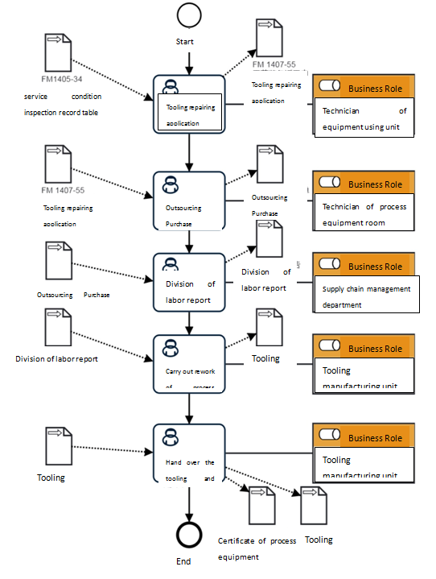
7.1 Tooling Repairing process
7.1.1 Tooling Repairing Flow Chart
7.1.2 Tooling Repairing Process Description Table
（1）Tooling repairing application
Tooling repairing application | Step description | According to the service condition inspection record table and maintenance point inspection table of the tooling , propose Tooling repairing application。
Tooling repairing application | Activity frequency | 3days
Tooling repairing application | Process role | Use unit technology | Position | N/A
Tooling repairing application | Input Material | Inspection Record of Tooling Usage、Fixture Maintenance Spot Check Table | Output Material | Tooling repairing application
Tooling repairing application | Compliance Terms | N/A
Tooling repairing application | Standard For Homework Execution | N/A
Tooling repairing application | Risk And Response Measures Available | N/A
（2）Outsourcing Purchase Requisition
Outsourcing Purchase Requisition | Step description | According to Tooling repairing application，propose Outsourcing Purchase Requisition。
Outsourcing Purchase Requisition | Activity frequency | 7days
Outsourcing Purchase Requisition | Process role | Technician of process equipment room | Position | N/A
Outsourcing Purchase Requisition | Input Material | Tooling repairing application | Output Material | Outsourcing Purchase Requisition
Outsourcing Purchase Requisition | Compliance Terms | N/A
Outsourcing Purchase Requisition | Standard For Homework Execution | N/A
Outsourcing Purchase Requisition | Risk And Response Measures Available | N/A
（3）Division of labor report
Division of labor report | Step description | According to Outsourcing Purchase Requisition，determine the supplier and issue Division of labor report。
Division of labor report | Activity frequency | 40days
Division of labor report | Process role | Supply chain management department | Position | N/A
Division of labor report | Input Material | Outsourcing Purchase Requisition | Output Material | Division of labor report
Division of labor report | Compliance Terms | N/A
Division of labor report | Standard For Homework Execution | N/A
Division of labor report | Risk And Response Measures Available | N/A
（4）Carry out rework of process equipment
Carry out rework of process equipment | Step description | According to Division of labor report， Supplier Carry out rework of process equipment on site
Carry out rework of process equipment | Activity frequency | 30days
Carry out rework of process equipment | Process role | Tooling manufacturing unit | Position | N/A
Carry out rework of process equipment | Input Material | Division of labor report | Output Material | Tooling
Carry out rework of process equipment | Compliance Terms | N/A
Carry out rework of process equipment | Standard For Homework Execution | N/A
Carry out rework of process equipment | Risk And Response Measures Available | N/A
（5）Hand over the tooling and certificate to the user
Hand over the tooling and certificate to the user | Step description | According to the tooling and inspection application form , Hand over the tooling and certificate to the user
Hand over the tooling and certificate to the user | Activity frequency | 2days
Hand over the tooling and certificate to the user | Process role | Tooling manufacturing unit | Position | N/A
Hand over the tooling and certificate to the user | Input Material | Tooling | Output Material | Certificate of process equipment、Tooling
Hand over the tooling and certificate to the user | Compliance Terms | N/A
Hand over the tooling and certificate to the user | Standard For Homework Execution | N/A
Hand over the tooling and certificate to the user | Risk And Response Measures Available | N/A
8 Process role list of responsibilities
Role Name | responsibilities
Technician of equipment using unit | Propose Tooling repairing application
Technician of process equipment room | Propose Outsourcing Purchase Requisition
Supply chain management department | Find and determine supplier and distribute Division of labor report
Tooling manufacturing unit | Complete rework of process equipment and hand over process equipment certificate

8 Control of Records

8.1 The relevant record shall be completed and maintained according to the GLC231008.

